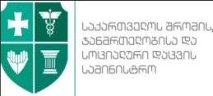 | 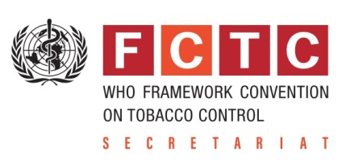

Implementation of
“FCTC 2030”
Project in Georgia

პროექტის „FCTC 2030-საქართველოს“
განხორციელება

David Sergeenko  Minister of Labour, Health and Social Affairs | Vera Luiza da Costa e Silva  Head of the Secretariat of the WHO Framework Convention on Tobacco Control

Tbilisi, Georgia
27 February, 2018

